21 When implementing linear regression of some dependent variable �� on the set of independent variables �� = (��₁, …, ��ᵣ), where �� is the number of predictors, which of the following statements will be true?

a) ��₀, ��₁, …, ��ᵣ are the **regression coefficients**.

b) Linear regression is about determining the **best predicted weights** by using the **method of ordinary least squares**.

c) E is the random interval

d) Both and b

**b)** Linear regression is about determining the best predicted weights by using the method of ordinary least squares.

22 )

What indicates that you have a **perfect fit** in linear regression?

a) The value ��² < 1, which corresponds to SSR = 0

b) The value ��² = 0, which corresponds to SSR = 1

c) The value ��² > 0, which corresponds to SSR = 1

d) The value ��² = 1, which corresponds to SSR = 0

**a)** The value ��² < 1, which corresponds to SSR = 0

A larger 𝑅² indicates a better fit and means that the model can better explain the variation of the output with different inputs.

The value 𝑅² = 1 corresponds to SSR = 0. That’s the **perfect fit**, since the values of predicted and actual responses fit completely to each other.

23)

Isimple linear regression, the value of **what** shows the point where the estimated regression line crosses the �� axis?

a) Y

b) B0

c) B1

d) F

**B) BO**

The value of 𝑏₀, also called the intercept, shows the point where the estimated regression line crosses the 𝑦 axis. It's the value of the estimated response 𝑓(𝑥) for 𝑥 = 0.

24)

Check out these four linear regression plots:

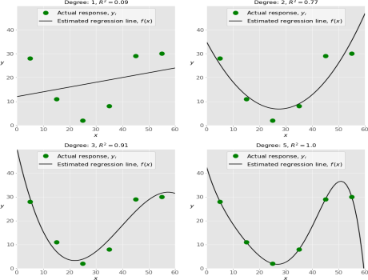Which one represents an **underfitted** model?

a)The bottom-left plot

b) The top-right plot

c) The bottom-right plot

d) The top-left plot

**b) The top-right plot**

Your model is underfitting the training data when the model performs poorly on the training data. This is because the model is unable to capture the relationship between the input examples (often called X) and the target values (often called Y).

25)

There are five basic steps when you’re implementing linear regression:

• **a.** Check the results of model fitting to know whether the model is satisfactory. • **b.** Provide data to work with, and eventually do appropriate transformations.

**c.** Apply the model for predictions.

• **d.** Import the packages and classes that you need.

• **e.** Create a regression model and fit it with existing data.

However, those steps are currently listed in the wrong order. What’s the correct order?

a) e, c, a, b, d

b) e, d, b, a, c

c) d, e, c, b, a

d) d, b, e, a, c

What are the steps to implement a linear regression?

1. Step 1: Load the data into R. Follow these four steps for each dataset: ...
2. Step 2: Make sure your data meet the assumptions. ...
3. Step 3: Perform the linear regression analysis. ...
4. Step 4: Check for homoscedasticity. ...
5. Step 5: Visualize the results with a graph. ...
6. Step 6: Report your results.

26 ) Which of the following are optional parameters to LinearRegression in scikit-learn?

a) Fit

b) fit_intercept

c) normalize

d) copy_X

e) n_jobs

f) reshape

following are optional parameters to LinearRegression in scikit-learn:

* **fit_intercept**: This parameter determines whether to calculate the intercept for the linear regression model. By default, it is set to True.
* **normalize**: This parameter determines whether to normalize the input features before fitting the model. By default, it is set to False.
* **copy_X**: This parameter determines whether to make a copy of the input features. By default, it is set to True.
* **n_jobs**: This parameter determines the number of parallel jobs to use for the computation. By default, it is set to None, which means it will use one job.

27) While working with scikit-learn, in which type of regression do you need to transform the array of inputs to include nonlinear terms such as ��²?

a)Multiple linear regression

b) Simple linear regression

c) Polynomial regression

**c) Polynomial regression**

Polynomial Regression With scikit-learnThere's only one extra step: you need to transform the array of inputs to include nonlinear terms such as 𝑥².

28) You should choose statsmodels over scikit-learn when:

A)You want graphical representations of your data.

b) You’re working with nonlinear terms.

c) You need more detailed results.

d) You need to include optional parameters

**c) You need more detailed results.**

Statsmodels provides more statistical information and is better suited for statistical analysis tasks.

29) _________ is a fundamental package for scientific computing with Python. It offers comprehensive mathematical functions, random number generators, linear algebra routines, Fourier transforms, and more. It provides a high-level syntax that makes it accessible and productive.

a) Pandas

b) Numpy

c) Statsmodel

d) scipy

**b) Numpy**

30 ) _________ is a Python data visualization library based on Matplotlib. It provides a high-level interface for drawing attractive and informative statistical graphics that allow you to explore and understand your data. It integrates closely with pandas data structures.

a) Bokeh

b) Seaborn

c) Matplotlib d) Dash

**b**) **Seaborn**